Independent Study: Latin Epigraphy
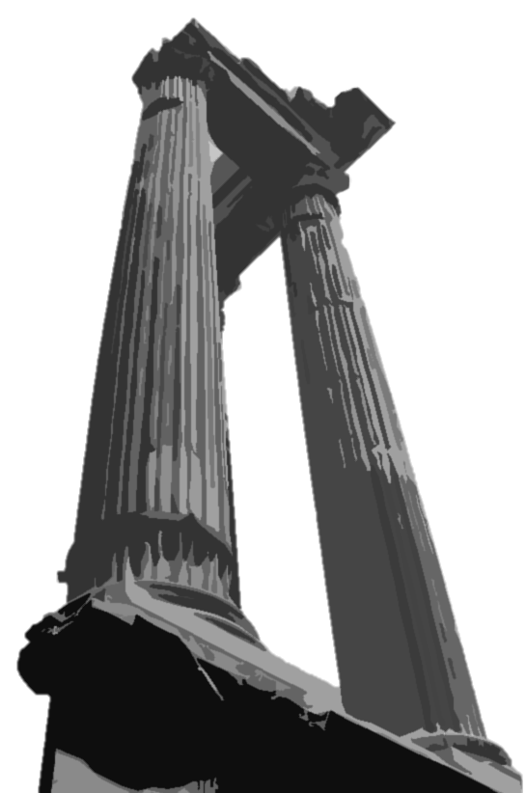
Instructor: Joey Williams
Contact: jwilliams@ou.edu
Meeting time: 1:45 on Fridays, Spring 2023 semester
Office hours: TTh 10:30-12:30

Course description: This independent study covers the inscriptions, graffiti, and informal texts of the Roman world. These texts will provide students with a unique window into public and private life throughout the ancient Mediterranean as well as first-hand experiences of ancient historical events both large and small.
Participants will first focus on the fundamentals of classifying, editing, and interpreting epigraphic texts. The seminar will cover the basics of studying inscriptions, the Roman epigraphic habit, the many different types of extant texts, and their manner of scholarly presentation. Students will be expected to engage with a wide variety of ancient texts presented in several different formats. This engagement will go beyond translation and will introduce participants to some of the most rigorous elements of classical scholarship and scholarship in the humanities generally.
Next, students will gather a collection of inscriptions through the use of online databases and the scholarly work known as the Corpus Inscriptionum Latinarum. Students will transcribe, translate, and curate their selection of Latin texts. Seniors will gain experience in the analysis of a diverse set of evidence, in the use of a complex citation and annotation systems, and in the presentation of their work to their peers. The class will culminate in a research paper that incorporates accurate transcription, translation, description, and analysis of participants’ epigraphic collection in its historical and cultural context.
Grading policy:

- Weekly inscription sets: 50%
- Final Paper: 50%

Course materials: Participants in the seminar are expected to bring a notebook, pen or pencil, and a Latin dictionary (a suggested dictionary is included below).
Suggested dictionaries (but any Latin dictionary should work fine!):
J. Traupman, The Bantam New College Latin & English Dictionary (3rd edition) - (Online for $3 used, $5 new)
J. Morwood, A Dictionary of Latin Words and Phrases - (Online for $1 used, $12 new)
D. P. Simpson, Cassell's Standard Latin Dictionary - (Online for $9 used, $15 new)

The following books are NOT REQUIRED, but students seeking a deeper understanding of Latin grammar and syntax are encouraged to acquire:
James B Greenough, J. H. Allen, G. L. Kittredge and A. A. Howard, Allen and Greenough's New Latin Grammar - (Online for $8 used, $15 new; free electronic copies of earlier editions are available!)
N. Goldman, English Grammar for Students of Latin (3rd edition) - (Online for $10 used; $15 new)
C. E. Bennett, New Latin Grammar - (Online for $1 used, $10 new)

Readings for this course will be drawn from a number of sources, including but not limited to the following books (foreign language sources will be provided in translation when necessary):
Berard, F. et al. 1989. Guide de l’epigraphiste: bibliographie choisie des epigraphies antiques et medievales. Paris.
Bodel, J. ed. 2001. Epigraphic Evidence: Ancient History from Inscriptions. London.
Cooley, A. E. 2012. The Cambridge Manual of Latin Epigraphy. Cambridge.
Gordon, A. E. 1988. Illustrated Introduction to Latin Epigraphy. Berkeley.
Hartnett, M. 2012. By Roman Hands: Inscriptions and Graffiti for Students of Latin (2nd edition). Newburyport.
Harvey, B. K. 2004. Roman Lives: Ancient Roman Life as Illustrated by Latin Inscriptions. Newburyport.
Keppie, L. 1991. Understanding Roman Inscriptions. Baltimore.
LaFleur, R. A. 2010. Scribblers, Sculptors, and Scribes. New York.
Lassère J.-M. 2005. Manuel d'épigraphie latine, 2 vol. Paris.
Susini, G. 1973. The Roman Stonecutter: An Introduction to Latin Epigraphy. Oxford.

Information regarding editing conventions for epigraphic study will be drawn from:
Dow, S. 1969. Conventions in editing: a suggested reformulation of the Leiden System. Greek, Roman and Byzantine Studies Scholarly Aids 2. Durham.
Krummery, H. and S. Panciera. 1980. “Criteri di edizione e segni diacritici.” Tituli 2: 205-15.
Panciera, S. 1991. Supplementa Italica 8: 8-21.
Woodhead, A. G. 1992. The Study of Greek Inscriptions. 2nd edition. Norman.

Epigraphic collections will be accessed from the following books and databases:
Printed collections of Latin epigraphy:
Corpus Inscriptionum Latinarum (CIL), 16 volumes.
Ephemeris Epigraphica (EphEp; EphemEpig), 9 volumes, 1872-1913.
L’Année Épigraphique (AE), previously a part of Revue Archeologique from 1888-1961, but an independent publication from 1962 to the present.
Inscriptiones Italiae (II), 14 volumes, 1931 to the present.
Supplementa Italica (SuppItal), 23 volumes from 1981-2007.
Inscriptiones Latinae Selectae (ILS; Dessau), 3 volumes in 5 parts.
Inscriptiones Graecae ad Res Romanas Pertinentes (IGRRP).
Hispania Epigraphica (HEp), 1989 to the present, possibly replaced by a website of the same name.

Internet resources for Latin epigraphy:
Epigraphik-Datenbank Clauss-Schlaby – over 350,000 Latin epigraphic texts: http://www.manfredclauss.de/
HispaniaEpigraphica – Latin epigraphy from Iberia (Spanish and English): http://www.eda-bea.es/
Corpus Inscriptionum Latinarum Online (German and English): http://cil.bbaw.de/ & http://www.arachne.uni-koeln.de/drupal/
Electronic Archive of Greek and Latin Epigraphy (Italian): http://www.eagle-eagle.it/
Epigraphic Database Bari – late antique and Christian epigraphy (Italian): http://www.edb.uniba.it/
American Society for Greek and Latin Epigraphy – resources for epigraphers: http://www.case.edu/artsci/clsc/asgle/
U.S. Epigraphy Project – epigraphic collections located in the United States: http://usepigraphy.brown.edu/
Prosopographia Imperii Romani (German): http://www.bbaw.de/bbaw/Forschung/Forschungsprojekte/pir/
Ubi Erat Lvpa – several different databases (primarily German): http://www.ubi-erat-lupa.org/
AEICL – Societas Internationalis Epigraphiae Graecae et Latinae (French): http://www.aiegl.com
Centre for the Study of Ancient Documents: http://www.csad.ox.ac.uk/
Current Epigraphy – a blog focusing on epigraphic study: http://www.currentepigraphy.org
Lacus Curtius – an personal site with a useful section on epigraphy: http://penelope.uchicago.edu/Thayer/E/Roman/home.html

Schedule of Classes: weekly meetings will cover inscriptions and their translation, as well as discussion of the topics below:

Introduction to Latin epigraphy, its study, and the history of the major collections
Editing conventions, the Leiden system, and difficulties in presentation
Ancient history from inscriptions
Pitfalls of epigraphic scholarship: “history from square brackets”
Everyday Latin: language and linguistics from inscriptions
The Roman “epigraphic habit”
The life and afterlife of Latin epigraphs: designing, cutting, reading, and viewing inscriptions
Categorizing texts: funerary, honorary, votive, and legal inscriptions
Graffiti, dipinti, tituli picti, and other forms of epigraphy
Epigraphy and archaeology: using inscriptions to establish chronology
The emergence of Christian epigraphy

The epigraphy of public and private life
Inscriptions relating to ancient religion
The epigraphy of identity, memory, and death
Inscriptions and the economy: texts of production, distribution, and ownership
The end of Latin epigraphy and the new symbols of commemoration
Epigraphy and modern life
Forming a research topic in Latin epigraphy: themes, methods, and practical considerations
Finding and editing published inscriptions
Navigating the Corpus Inscriptionum Latinarum (CIL) and other corpora
The problem of forgeries
Presenting epigraphic collections in various media

Standard editing conventions – you will refer to this page often!
Sigla Explanations
ạ Fragmentary letter, uncertain reading suggested by the epigrapher
+ Badly damaged letter, impossible to identify
ABC Letters are legible but impossible to interpret
abc Letters identified previously but no longer visible
âb Ligature, circumflex indicates one letter is joined to the next, such as the diphthong “Æ”
[abc] Letters missing because of damage, but supplied by the epigrapher
(abc) Expansion of an abbreviation supplied by epigrapher
((abc)) Letters or symbols represented differently on the stone
┌abc┐ Text corrected by the epigrapher
{abc} Letters included on the stone but removed by the epigrapher
<abc> Letters omitted on the stone but added by the epigrapher
[[abc]] Text erased in antiquity
«abc» Text inscribed over an erasure
[. . .] Missing letters, usually from damage, with each dot representing one letter
[- - -] Missing letters of an uncertain number
(vac.) Surface of the stone is blank – (vac. c. 5) indicates a space of approximately five letters
/ Text inscribed on a different line
// Text inscribed on a different face of the stone

